FYP Progress Report
P2P IPTV – TD1a-09



Project Supervisor : Prof. Danny Tsang
Signature : ___________________

Conducted by : Cheng Wen Chi, Vinci (07481136)
Chiu Kwok Shing (07323530)
Choi Kwok Yam, Alex (07483512)
Table of Contents
1 Overview 3
1.1 Introduction 3
1.2 Aim and Objectives 3
1.3 System Block Diagrams 3
1.4 Design specifications 4
1.5 Report Outline 4
2 Background 5
3 Reference 7

1 Overview
  - Introduction
Recently, Peer to Peer (P2P) Protocol is the hottest topic in networking field. P2P has a great advantage over the traditional client-server model. In P2P model, clients will work as a part of service provider when they join into the mesh network.

Currently, the market of IPTV is expanding in different countries. IPTV delivers a low delay online video service. The service requires a very high bandwidth and processing power from the server. For P2P model, it provides suitable platform for this kind of large amount of data transfer. By using P2P model, the required network resource from the server will be reduced. Thus, the server will be able to support more users with the same amount of resource.
PPStream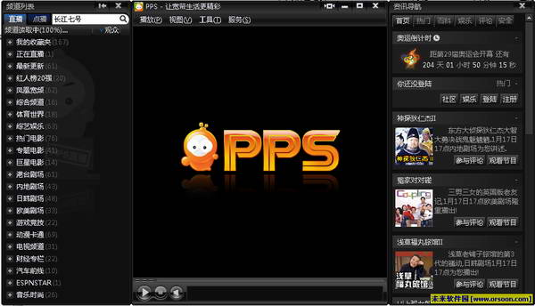

PPLive
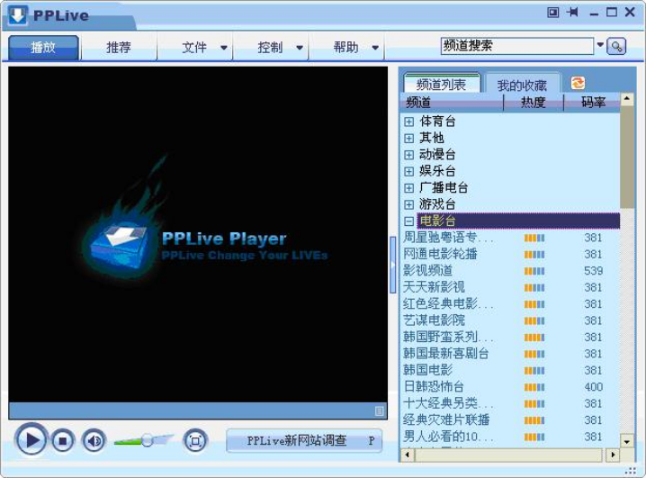

  - Aim and Objectives

In this project, we are going to build up a program to provide IPTV service in P2P model that provides user-friendly and high quality IPTV service.

Since PC hardware and Internet is getting more efficient, home users have a thirst for a higher quality of online video service. Currently, most P2P IPTV software provides limited quality online video service. However, broadband internet service is popularizing in Hong Kong. At the same time, the power of personal computer grow up quickly, home user have a thirst for a higher quality of online video service.

  - System Block Diagrams

Still missing the Block Diagram, I will provide it later………..

  - Design specifications

Components of the P2P IPTV
- Tracker Servers
  - Store IP address of all users that join the P2P network
  - Provide new user a list of peers that they can join into the P2p network.
- Video Servers
  - Stream out the seed of video into the network.
- Peer side application
  - User interface that can select channels and watching high quality video.
  - Joining the P2P network, upload the video to the peers in the same time it download the video to facilitate the quality of whole network.
  - Report Outline

There are 4 chapters in this report. In the chapter you just finished give you a basic concept about P2P IPTV and what we are going to achieve.

Here is the outline of the following chapters:

Chapter 2: Some background information of the project.
Chapter 3: Methodology that we take to achieve our goal
Chapter 4: The current progress of us, what we have done for each member in the group.
- Background
P2P model is widely used on file or data sharing in modern internet. In P2P model, clients become one of the participators in data upload. Transmission speed is no longer based on server throughput (server-client model), but shifted to the throughput of both peers and server. Theologically, the performance of P2P network will be even improved with the increased number of peers. As bandwidth of client computers are increased rapidly in the past years, it optimized the working environment for P2P model. Workload and dependence of server throughput is also reduced by P2P model. As a result, a much stable and high data throughput can be achieved in the same topology.

Entertainment has become the main function of home PC. Online Movie, TV, music are common home entertainments. Users enjoy different kinds of online entertainments through their broadband connection in different countries. Most of the online multimedia applications need to deliver a large amount of time sensitive data. The multimedia streaming leads to a significant problem for server to deliver a stable service to large number of clients. P2P model is then become one of the most feasible solutions for multimedia data delivery. IPTV is a signification example of multimedia streaming that benefit from the P2P model. In the past, it is infeasible to deliver real time TV broadcast through internet. The throughput of server does not meet needs of high bit rate of client in client-server model. However, after P2P model is applied, the throughput of download stream in each clients have significant increase, and data streaming is then allowed to support the high bit rate of video. As a result, most of the popular P2P IPTV systems are using P2P model to provide their service.

High and stable throughput of data streaming is critical factor of P2P IPTV performance. The construction of P2P streaming network will drive the performance of data streaming. This means construction of P2P streaming network is most important for P2P IPTV.

There are 2 major design issues for constructing a P2P streaming network:
- how to form an overlay topology between peers
- how to deliver video content efficiently
According to the researches [3] [4], there are 2 common basic approaches to construct P2P network, mesh pull and tree push. For tree push, peers are connected in tree-shaped overlay and video data is pushed out from root (server) to peers by passing through the tree hierarchy. For mesh pull, peers form a mesh-shaped overlay and they pull video from each other by send request to peer.
Recently, there are numbers commercial P2P IPTV has been successfully deployed. According to articles [1][2], those IPTV users are increased exponentially in these few years. PPStream, PPlive, SopCast are the examples of the common P2P IPTV. Most of them applied the mesh pull algorithm to deliver the service, moreover applying TCP to ensure the reliability of delivery. The mesh-pull system is popular for P2P IPTV as it is relatively simpler design principle than tree push. However, they reached some common problems, such as large initial delay, high reconnection latency and high disconnection rate.

In this project, our aim is to implement a high quality and stable IPTV system with a optimize P2P model. After studying the academic research [4], it indicates tree-push provide a better performance in practice. Tree push cause a lesser overhead in data streaming over mesh pull and it will be further discuss on methodology part. Our project will deploy with base which used tree push system and provide further enhance with several algorithms. These algorithms include multiple trees model, data sub streaming, and MDC (multiple description coding). The approach to implement these algorithms will also be clarified in the methodology section of the report.
- Reference
[1] Laurie Gonzalez, Marketing Director of the Broadband Forum Asia, “IPTV DEPLOYMENTS DOUBLE FOR THE SECOND YEAR RUNNING AS BROADBAND CONTINUES TO ACHIEVE STRONG GROWTH”, 15 July 2008
http://www.broadband-forum.org/news/download/pressreleeases/2008/IPTV_Deployments_Double07_15_08.pdf
[2] Internet Protocol Television (iPTV) - Global Strategic Business Report, Global Industry Analysts, Inc., March 2008, Pages: 458 http://www.researchandmarkets.com/reportinfo.asp?report_id=347969&t=t&cat_id=
[3] Xiao jun Hei, Yong Liuz and Keith W. Ross:” IPTV over P2PStreaming Networks: the Mesh-pull Approach”, Communications Magazine, IEEE, Vol. 46, No. 2. (2008)
[4] ZhenjiangLi, YaoYu, XiaojunHei, and Danny Hin-Kwok Tsang: “A Uniﬁed Framework for Sub-stream Scheduling in P2PHybrid Streaming Systems and How to Do Better?”, P. 728-741, 7th May 2009

